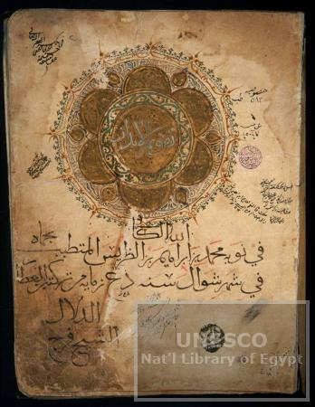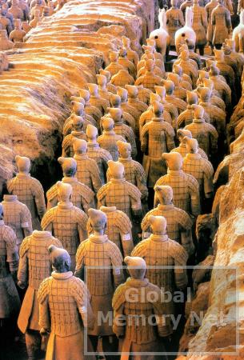

Digital Media Resources for Teaching Global Area Studies:
Global Memory Net and World Heritage Memory Net

Dr. Ching-chih Chen
Professor, Graduate School of Library and Information Science, Simmons College
Principal Investigator and Project Director, Global Memory Net
Director, World Heritage Digital Center

In articulating the use of digital media resources for teaching global area studies, Dr. Ching-chih Chen will draw upon the experience of her internationally known US National Science Foundation’s International Digital Library Project, Global Memory Net and the latest activities of the first US World Heritage Digital Center in partnership with the UNESCO’s World Heritage Center.

Global Memory Net currently has documented collections related to many major cultural, heritage and historical collections in the world, including:

- The First Emperor of China’s terracotta warriors and horses;
- UNESCO’s Memory of the World which documenting invaluable collections from over 100 countries,
- Library of Congress’s Asian Division’s invaluable collections of Naxi (China), Inoh Maps of Japan, etc.
- UNESCO and National Library of Egypt’s Islamic Manuscripts,
- 54 minority ethnic groups in Vietnam by using all the arts and artifacts from the Vietnam National Museum of Ethnology,
- 2400 digital collections from over 80 countries ….

Most recently, in partnership with the World Heritage Center of UNESCO, the first US World Heritage Digital Center is using the Global Memory Net technology to link the 830 world heritage sites of 138 countries. Many of these sites relate to the threatened culture and heritage of the world, and are of particular interest to Islamic and Asian studies.

Friday, April 27, 2007
5:30-6:45 pm
Meyer Auditorium, Lake Forest College

